**Assignment No: - 2**

**Facial Recognition using OpenCV**

**Name: Shubhankar Jakate**

**Roll no: 382019**

**Problem Statement:**

Facial Recognition Using OpenCV and Deep Learning for Binary Classification.

**Objective:**

* Understand the fundamentals of face detection and recognition.
* Learn to preprocess face data and extract facial embeddings.
* Implement a deep learning-based model to classify faces.
* Evaluate the model's accuracy and performance.
* Visualize the training process and performance metrics.

**S/W Packages and H/W apparatus used:**

* **Operating System:** Windows/Linux/MacOS
* **Kernel:** Python 3.x
* **Tools:** Jupyter Notebook, Anaconda, or Google Colab
* **Hardware:** CPU with minimum 4GB RAM; optional GPU for faster processing

**Libraries and packages used:**

* **TensorFlow/ Keras**
* **OpenCV**
* **Dlib**
* **face_recognition**
* **NumPy**
* **Pandas**
* **Matplotlib**
* **Scikit-Learn**

**Theory:**

**Definition:** A facial recognition system is a technology capable of identifying or verifying a person from a digital image or video frame. The system works by detecting facial features and matching them against a pre-stored database. In binary classification, the task is to distinguish between two classes, typically "face" and "no face."

**Structure:** It consists of:

* **Face Detection Module:** Detects the presence of a face in the input image using techniques like Haar Cascades or deep learning models (SSD or YOLO).
* **Feature Extraction Module:** Extracts unique facial features from the detected region using Convolutional Neural Networks (CNNs).
* **Classification Module:** Binary classifier (CNN or SVM) that outputs whether the detected region contains a face or not.

**Activation Functions:** Functions like ReLU (Rectified Linear Unit), Sigmoid, and SoftMax are used to introduce non-linearity into the classification model, enabling it to learn complex patterns.

**Backpropagation:** A critical algorithm for training the CNN-based model, where the error between predicted and true labels is propagated backward to update the weights in each layer to minimize classification error.

**Methodology:**

1. **Data Collection:** Gather a dataset containing face and non-face images.
2. **Preprocessing:** Use OpenCV for face detection and resize images to a uniform size. Normalize pixel values.
3. **Model Architecture:** Build a CNN using Keras/TensorFlow to classify images as face or no face.
4. **Training:** Train the model with labeled images, using binary cross-entropy loss and accuracy as a metric.
5. **Evaluation:** Test the model's performance using unseen data, evaluating accuracy and other metrics.
6. **Prediction:** Use the trained model to classify new images as containing a face or not.

**Advantages:**

* **High Accuracy:** Deep learning provides high precision in recognizing and classifying faces.
* **Real-Time Processing:** OpenCV allows for real-time face detection and recognition.
* **Automation:** The system can automate tasks such as authentication and access control.

**Limitations:**

* **Data Quality and Quantity:** Facial recognition systems require a large, diverse, and high-quality dataset for training. Poor-quality images or insufficient training data can lead to inaccurate predictions and difficulty in generalizing to new faces.
* **Illumination and Pose Variability:** Variations in lighting, pose, facial expressions, and occlusions (like glasses or hats) can significantly affect the model's accuracy, leading to false positives or false negatives.
* **Privacy Concerns:** Facial recognition technology raises significant ethical and privacy issues. The unauthorized collection and use of facial data can infringe on personal privacy rights, leading to regulatory and legal challenges.
* **Computational Complexity:** Deep learning-based facial recognition models, especially with large-scale datasets, require significant computational resources for training and deployment, which may not be suitable for real-time or low-power devices.
* **Overfitting:** If the model is overly complex or trained on limited or biased data, it can overfit to the training data, resulting in poor performance on real-world or unseen images.
* **Adversarial Vulnerabilities:** Facial recognition systems can be susceptible to adversarial attacks, where small perturbations in the image can fool the system into misclassifying a face.

**Applications:**

* **Security and Surveillance:** Facial recognition is widely used in security systems for access control, identifying individuals in surveillance footage, and monitoring high-security areas.
* **Biometric Authentication:** Facial recognition is employed in smartphones, laptops, and other devices for user authentication, providing a convenient and secure alternative to passwords.
* **Law Enforcement:** Police and other law enforcement agencies use facial recognition to identify suspects in criminal investigations, locate missing persons, or track criminals across large datasets.
* **Healthcare:** Facial recognition can be used in healthcare to monitor patient conditions, detect emotional states, and assist in diagnosing genetic disorders based on facial features.
* **Retail and Marketing:** In retail environments, facial recognition is used for personalized marketing, customer identification, and enhancing customer experience by analyzing shopping patterns.
* **Time and Attendance Systems:** Many businesses employ facial recognition for tracking employee attendance and enhancing workplace security by automating time-in/time-out processes.
* **Smart Cities:** Facial recognition technology can be integrated into smart city infrastructure for traffic monitoring, crowd control, and improving public safety.

**Working / Algorithm:**

**Step 1: Install Necessary Libraries**

* OpenCV is installed for image processing, and TensorFlow is installed for building the neural network model.

**Step 2: Live Face Detection Using Webcam**

* JavaScript code is executed to access the webcam and capture a photo.
* The captured image is converted into an OpenCV format for further processing.
* A pre-trained face detection model (Haar Cascade) is used to detect faces in real-time by converting the captured image to grayscale and identifying facial regions.

**Step 3: Load and Preprocess Dataset**

* A custom dataset is loaded from the local directory containing images of faces in two categories (e.g., happy and sad).
* The images are resized to 128x128 pixels and converted to grayscale. Non-image files are skipped, and any problematic images are handled with error messages.
* The pixel values of the images are normalized to scale between 0 and 1.

**Step 4: Label Encoding**

* Labels corresponding to the classes (e.g., happy and sad) are one-hot encoded to create binary labels for classification.

**Step 5: Split Data into Training and Testing Sets**

* The dataset is divided into training (80%) and testing (20%) sets, ensuring the labels are stratified to maintain class balance.

**Step 6: Define CNN Architecture**

* A Convolutional Neural Network (CNN) is defined using the Sequential API from Keras:
  + Three convolutional layers are used with filters of sizes 32, 64, and 128, all using ReLU activation.
  + Max-pooling layers are used after each convolutional layer to downsample the feature maps.
  + The model is flattened to transition to fully connected layers, followed by a dense layer with 256 units.
  + A dropout layer is added to prevent overfitting.
  + The output layer uses Softmax activation for binary classification (happy or sad).

**Step 7: Compile the** **Model**

* The CNN model is compiled using the Adam optimizer, binary cross-entropy as the loss function (since this is a binary classification problem), and accuracy as the performance metric.

**Step 8: Train the Model**

* The model is trained on the training dataset for 15 epochs. The validation set (testing data) is used to monitor the model’s performance after each epoch.

**Step 9: Evaluate the Model**

* After training, the model is evaluated on the test data, and the test accuracy is computed.

**Step 10: Save the Model**

* The trained CNN model is saved to a file for future use.

**Step 11: Make Predictions on New Data**

* A single image (e.g., of a sad person) is loaded, preprocessed (resized and normalized), and passed through the model to predict the class. The predicted class (happy or sad) is printed, and the corresponding image is displayed.

**Step 12: Display the Final Results**

* The accuracy of the model on the test data is printed, indicating the performance of the model on unseen data.

**Diagram:**

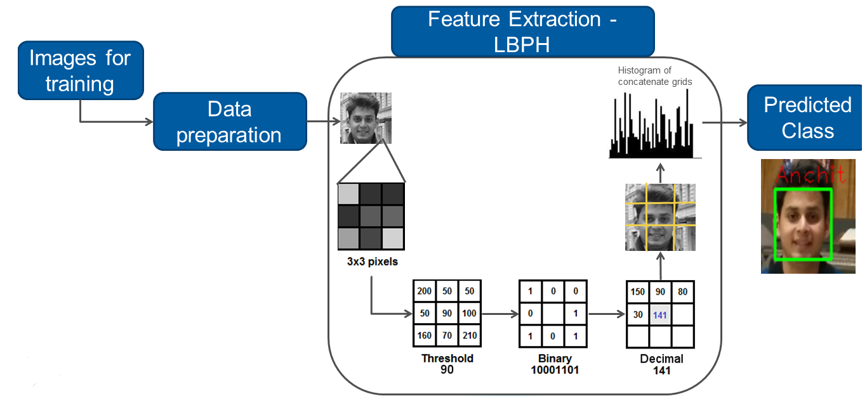

**Conclusion:**

The OpenCV-based facial recognition system is a powerful and efficient tool for recognizing faces in real-time. Leveraging classical computer vision techniques such as Haar Cascades or deep learning-based models, OpenCV can effectively detect and recognize facial patterns. Its strength lies in its speed and versatility, making it suitable for various applications like surveillance, access control, and user authentication. However, challenges like varying lighting conditions, occlusions, and the need for pre-trained models to achieve high accuracy must be considered. With proper optimization, OpenCV can provide reliable and scalable facial recognition solutions across different industries.